Michael Smith

CSE 460

Homework 2

Total Points: 60

1.) Write a simple shell that is similar to what we have discussed in class?

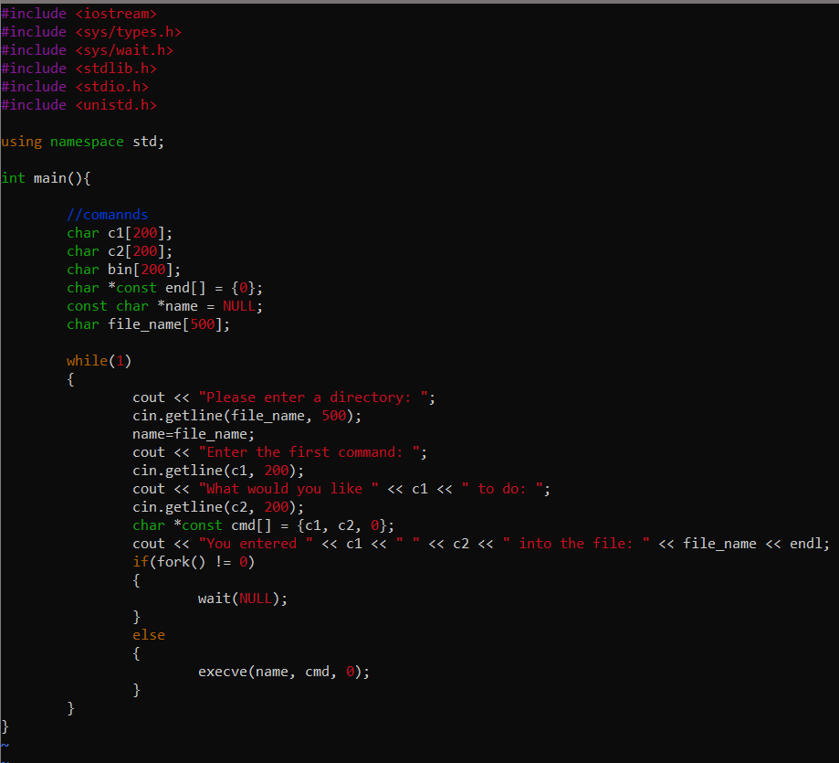

Output

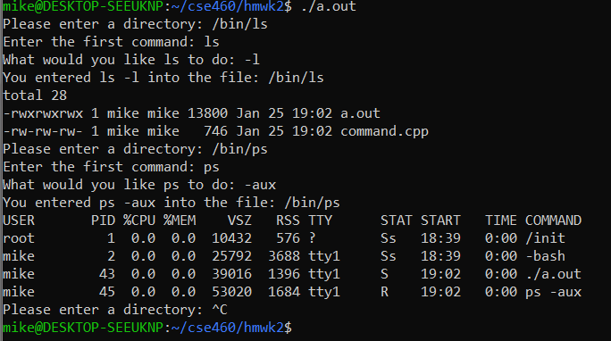

2.) Suppose that the following processes arrive for execution at the times indicated. Each process will run the listed amount of time. In answering the questions, use nonpreemptive scheduling and base all decisions on the information that you have at the time the decision must be made.

1. What is the average **waiting** time for these processes with the FCFS scheduling algorithm?

Gantt Chart

|  |  |  |
| --- | --- | --- |
| P1 | P2 | P3 |

|  |  |  |  |
| --- | --- | --- | --- |
| 0 | 8 | 12 | 13 |

|  |  |
| --- | --- |
| Process | Wait Time |
| P1 | 0 |
| P2 | 8.6 |
| P3 | 11 |

Total = 18.6 units Average Time = 18.6/3 = 6.2 units

1. What is the average **waiting** time for these processes with the SJF scheduling algorithm?

Gantt Chart

|  |  |  |
| --- | --- | --- |
| P1 | P2 | P3 |

|  |  |  |  |
| --- | --- | --- | --- |
| 0 | 8 | 9 | 13 |

|  |  |
| --- | --- |
| Process | Wait Time |
| P1 | 0 |
| P2 | 8.6 |
| P3 | 7 |

Total = 15.6 units Average Time = 15.6/3 = 5.2 units

1. The SJF algorithm is supposed to improve performance, but notice that we chose to run process P1 at time 0 because we did not know that two shorter processes would arrive soon. Compute what the average **waiting** time will be if the CPU is left idle for the first 1 unit, and then SJF scheduling is used. Remember that processes P1 and P2 are waiting during this idle time, so their waiting time may increase. This algorithm could be known as future-knowledge scheduling.

Gantt Chart

|  |  |  |  |
| --- | --- | --- | --- |
| Idle | P3 | P2 | P1 |

|  |  |  |  |  |
| --- | --- | --- | --- | --- |
| 0 | 1 | 2 | 6 | 14 |

|  |  |
| --- | --- |
| Process | Wait Time |
| P1 | 5 |
| P2 | 1.6 |
| P3 | 1 |

Total = 7.6 units Average Time = 7.6/3 = 2.53 units

3.) Consider the following set of processes, with the length of the CPU-burst time given in milliseconds.

|  |  |  |
| --- | --- | --- |
| Process | Burst Time | Priority |
| P1 | 10 | 3 |
| P2 | 1 | 1 |
| P3 | 2 | 3 |
| P4 | 1 | 4 |
| P5 | 5 | 2 |

1. Draw four Gantt charts that illustrate the execution of these processes using FCFS, SJF, a nonpremptive priority ( a smaller number implies higher priority ), and RR ( quantum = 1 ) scheduling.

FCFS Gantt Chart

|  |  |  |  |  |
| --- | --- | --- | --- | --- |
| P1 | P2 | P3 | P4 | P5 |

|  |  |  |  |  |  |
| --- | --- | --- | --- | --- | --- |
| 0 | 10 | 11 | 13 | 14 | 19 |

SJF

|  |  |  |  |  |
| --- | --- | --- | --- | --- |
| P2 | P4 | P3 | P5 | P1 |

|  |  |  |  |  |  |
| --- | --- | --- | --- | --- | --- |
| 0 | 1 | 2 | 4 | 9 | 19 |

Non-Preemptive

|  |  |  |  |  |
| --- | --- | --- | --- | --- |
| P2 | P5 | P1 | P3 | P4 |

|  |  |  |  |  |  |
| --- | --- | --- | --- | --- | --- |
| 0 | 1 | 6 | 16 | 18 | 19 |

Round Robin

Part 1

|  |  |  |  |  |  |  |  |  |
| --- | --- | --- | --- | --- | --- | --- | --- | --- |
| P1 | P2 | P3 | P4 | P5 | P1 | P3 | P5 | P1 |

|  |  |  |  |  |  |  |  |  |  |
| --- | --- | --- | --- | --- | --- | --- | --- | --- | --- |
| 0 | 1 | 2 | 3 | 4 | 5 | 6 | 7 | 8 | 9 |

Part 2

|  |  |  |  |  |  |  |  |  |
| --- | --- | --- | --- | --- | --- | --- | --- | --- |
| P5 | P1 | P5 | P1 | P5 | P1 | P1 | P1 | P1 |

|  |  |  |  |  |  |  |  |  |  |
| --- | --- | --- | --- | --- | --- | --- | --- | --- | --- |
| 10 | 11 | 12 | 13 | 14 | 15 | 16 | 17 | 18 |  |

Part 3

|  |
| --- |
| P1 |
| 19 |

1. Calculate the turnaround time of each process for each of the scheduling algorithms in part a).

FCFS

|  |  |
| --- | --- |
| Process | Turn Around Time |
| P1 | 10 |
| P2 | 11 |
| P3 | 13 |
| P4 | 14 |
| P5 | 19 |

Total = 67 units Average Time = 67/5 = 13.4 units

SJF

|  |  |
| --- | --- |
| Process | Turn Around Time |
| P1 | 19 |
| P2 | 1 |
| P3 | 4 |
| P4 | 2 |
| P5 | 9 |

Total = 35 units Average Time = 35/5 = 7 units

Non-Preemptive

|  |  |
| --- | --- |
| Process | Turn Around Time |
| P1 | 16 |
| P2 | 1 |
| P3 | 18 |
| P4 | 19 |
| P5 | 6 |

Total = 60 units Average Time = 60/5 = 12 units

RR

|  |  |
| --- | --- |
| Process | Turn Around Time |
| P1 | 19 |
| P2 | 2 |
| P3 | 7 |
| P4 | 4 |
| P5 | 14 |

Total = 46 units Average Time = 46/5 = 9.2 units

1. Calculate the waiting time of each process for each of the scheduling algorithms in part a).

FCFS

|  |  |
| --- | --- |
| Process | Turn Around Time |
| P1 | 0 |
| P2 | 10 |
| P3 | 11 |
| P4 | 13 |
| P5 | 14 |

Total = 48 units Average Time = 48/5 = 9.6 units

SJF

|  |  |
| --- | --- |
| Process | Turn Around Time |
| P1 | 9 |
| P2 | 0 |
| P3 | 2 |
| P4 | 1 |
| P5 | 4 |

Total = 16 units Average Time = 16/5 = 3.2 units

Non-Preemptive

|  |  |
| --- | --- |
| Process | Turn Around Time |
| P1 | 6 |
| P2 | 0 |
| P3 | 16 |
| P4 | 18 |
| P5 | 1 |

Total = 41 units Average Time = 41/5 = 8.2 units

RR

|  |  |
| --- | --- |
| Process | Turn Around Time |
| P1 | 19 |
| P2 | 2 |
| P3 | 7 |
| P4 | 4 |
| P5 | 14 |

Total = 27 units Average Time = 27/5 = 5.4.4 units

1. Which of the schedules in part a) results in the minimal average waiting time ( over all processes )?

The SJF scheduling algorithm has the shortest waiting time with a 3.2 units, making it significantly shorter than the rest of the algorithms.

Eval: I believe that I earned a 60/60 on this assignment. I was able to answer each question and provide all the right data for each part.